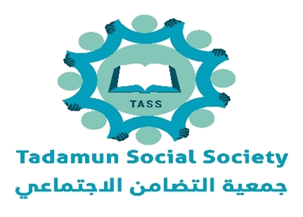
Making the Dream of Prosperity into Reality.

WATER, SANITATION AND HYGIENE | LAAS QORAY, SANAAG | MAY 2026
After Three Failed Rainy Seasons, Water Flows Again in Laas Qoray
How TASS, with funding from the Somalia Humanitarian Fund, restored permanent water sources, delivered emergency relief, and put community committees in charge of what comes next.
 Why this work mattered
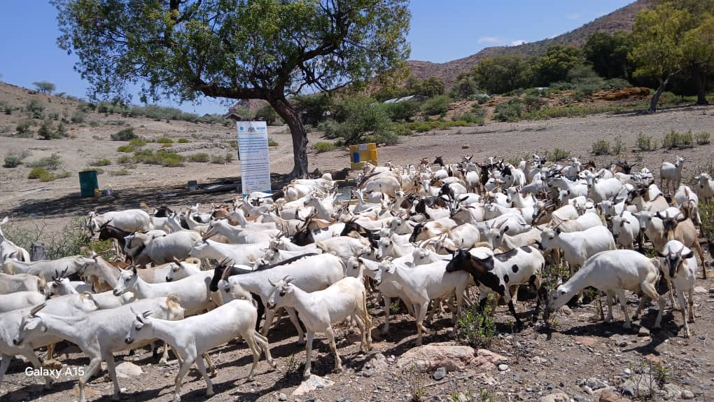
A herd of goats drinks water at a newly developed livestock trough in Ulxeed Village, Laas Qoray district. Photo Courtesy of TASS
After three failed rainy seasons in a row across Sanaag Region of Somalia, livestock had began dying in numbers families could not count. Berkeds stood empty. Women and girls walked further each day for water, and the water they found was rarely clean. Boreholes that once served whole villages stood silent. The borehole in Ulxeed had been dormant for three years. Households were paying private vendors prices they could no longer afford.
This was the situation TASS faced in December 2025 when work began on a seven-month emergency WASH response in Laas Qoray, funded by the Somalia Humanitarian Fund (SHF) under project CBPF-SOM-25-R-NGO-38186 with a budget of USD 303,999.
 Who the project serves, and where
The project set out to reach 16,254 highly vulnerable people across ten settlements in Laas Qoray District, Sanaag region. The targeted villages, Ceelaayo, Buraan, Durduri, Ulxeed, Habarshiro, Kaladhacda, Sibaayo, Balibusle, Caadsaaran, and the Dhanaha IDP camp, are pastoralist settlements where drought stripped families of their herds and of the means to buy water from private vendors.
Selection followed Vulnerability Based Targeting (VBT). Households with acutely malnourished children, pregnant and breastfeeding women, homebound elderly people, and people living with disabilities (PLWDs) took priority. Beneficiary lists were validated jointly with community committees rather than imposed from outside.
WHO THE PROJECT REACHES
16,254 highly vulnerable people across ten settlements in Laas Qoray District.
6,339  Women (≥18) | 3,345  Girls (<18) | 3,306  Men (≥18) | 3,264  Boys (<18)

5,661  IDPs | 7,965  Host community | 115  Refugees & returnees | 1,118  Persons living with disabilities
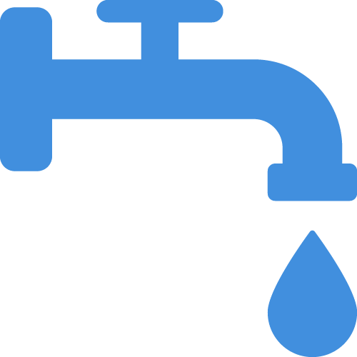 What TASS did — three integrated streams
TASS designed the response as three linked streams of work, each addressing a different layer of the crisis.

Restoring permanent water sources
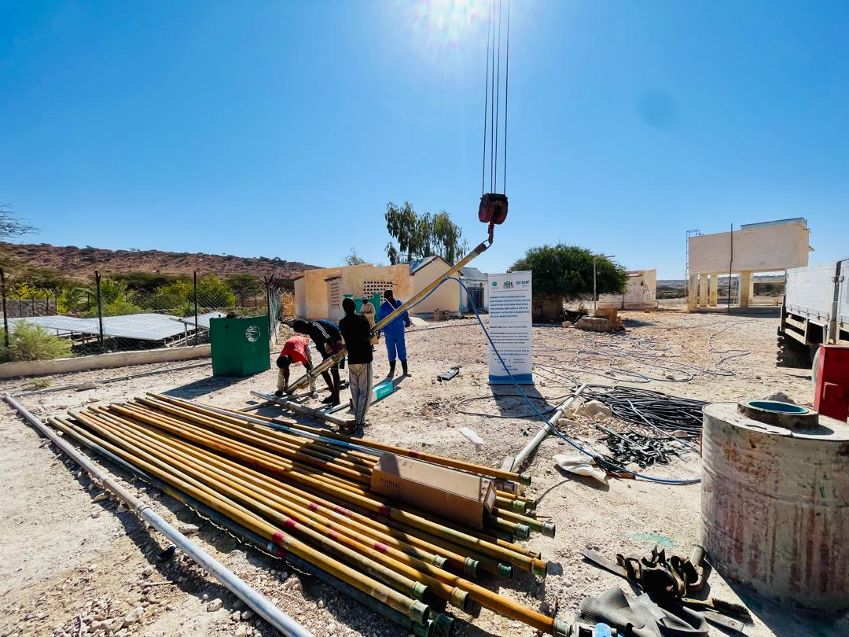Field photo of borehole rehabilitation in Buraan. Photo Courtesy of TASS

TASS developed a new 10-metre shallow well in Durduri, rehabilitated a borehole in Ulxeed that had been dormant for three years, and refurbished the Buraan borehole with a new 7.5 kW submersible pump. A 40 cubic metre elevated storage tank in Ceelaayo was structurally repaired, fitted with new control valves, and repainted. TASS also replaced 4,500 metres of deteriorated water pipeline in Ceelaayo and Buraan. 3,000 metres of pipeline was replaced in Ceelaayo and 1,500 metres in Buraan, eliminating the systemic leakage that had quietly drained the network for years.
Answering immediate thirst
TASS delivered 4,800,000 litres of safe drinking water by truck over ninety days to 3,555 people in six locations, Habarshiro, Balibusle, Sibaayo, Kaladhacda, Caadsaaran, and the Dhanaha IDP camp while construction crews worked to restore permanent water sources. The volume met the SPHERE minimum of fifteen litres per person per day. Trucking ran from 15 December 2025 to 15 March 2026 under daylight-only schedules to reduce protection risks for women and girls collecting water.
Making the water safe at home
TASS distributed 16,000 Aqua Tabs to 4,000 households across all ten target villages and ran hygiene promotion sessions in local Somali dialects. By the end of the distribution exercise, 85 percent of participants showed improved knowledge of safe storage and treatment, exceeding the project target of 80 percent.
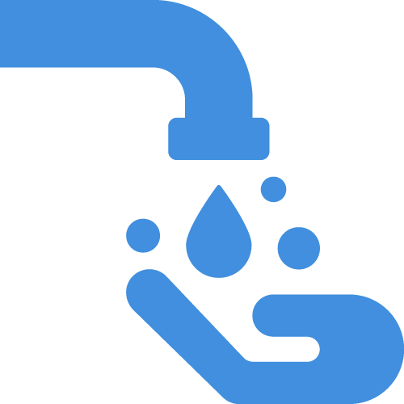 How — dignity, accountability, sustainability
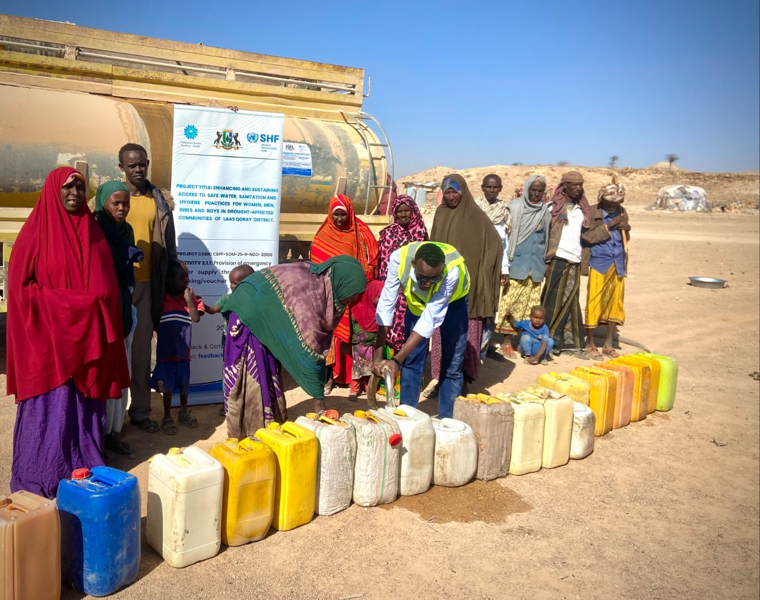Residents of Dhanaha IDP camp queue to collect emergency potable water from a truck. Photo Courtesy of TASS

Every water point built or rebuilt under this project carries the same set of features which include non-slip aprons and low-level tap stands. In Durduri and Ulxeed a livestock trough sits alongside the human kiosk. These details mean a woman in a wheelchair, an elderly man with a cane, and a herding boy with a goat can all draw water at the same point without risk. SPHERE benchmarks now hold across all rehabilitated sites, with fifteen litres per person per day, collection points within 500 metres of the dwelling, and round-trip collection times under thirty minutes.
TASS trained 120 WASH committee members, 53 women and 57 men, in pump operation, solar maintenance, chlorination, and financial oversight to enhance sustainability of the project. Half the seats are mandated for women, and representation of people living with disability is built into selection. A twelve-month maintenance fund will transfer to community management at handover, with continuing technical oversight from the Puntland Water Development Agency (PWDA).
Accountability runs through the model. Awareness sessions on Prevention of Sexual Exploitation and Abuse (PSEA), gender-based violence risk mitigation, and the Complaints and Feedback Mechanism reached 200 community members in two cycles, with a third cycle following in June 2026. Female mobilisers led sensitive conversations, and visual aids and role plays carried the messages where written materials could not. Beneficiaries can report concerns through the toll-free hotline 325, by email at feedback@tadamun.org, or in person at the AAP help desk on each site.
 What happens next
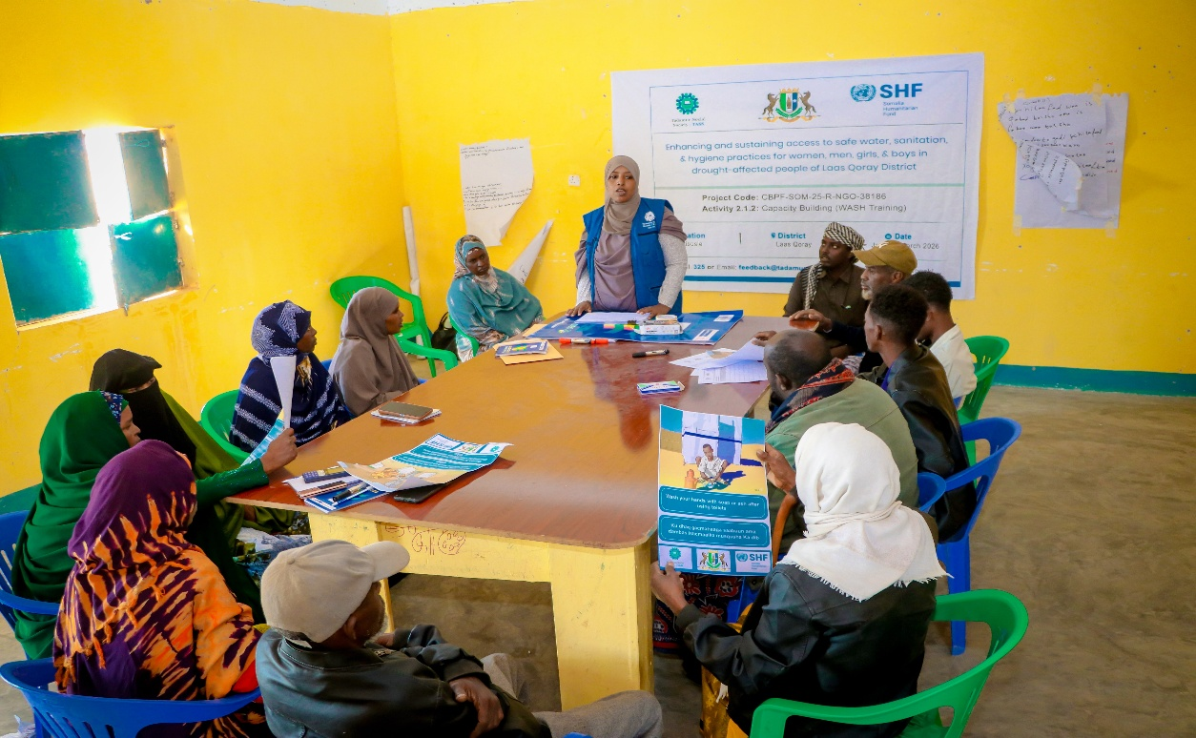
WASH committee members in Balibusle Village participate in a capacity building training. Photo Courtesy of TASS

By 30 June 2026, when the project closes, water will be flowing through 4,500 metres of new pipeline in Buraan, Ceelaayo, Durduri and Ulxeed drawn from rehabilitated boreholes and new shallow well in Durduri. The next milestone is the formal handover of water infrastructure to the trained WASH committees. Each community will hold the toolkit, the maintenance fund, and the technical knowledge to keep the system running after TASS steps back.
FUNDING
Project CBPF-SOM-25-R-NGO-38186 is funded by the Somalia Humanitarian Fund (SHF), a Country-Based Pooled Fund managed by OCHA. Implementation period: 1 December 2025 to 30 June 2026.

